**Med Chain**

**Patient-led health transformation**



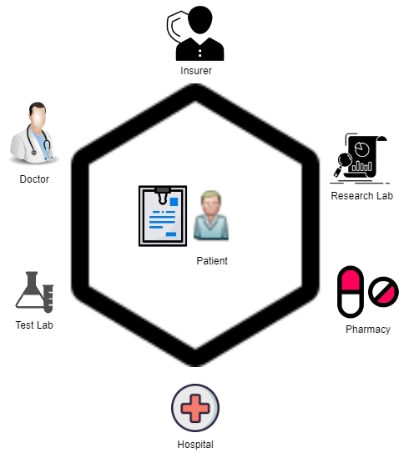What we want!

* Empower Patients
* Patients control their the data
* Uncorrupt system using Blockchain

# Problems in healthcare systems



* **Security & Frauds** - Security breach, ransom attacks, insurance frauds. NHS lost 700,000 records in 2017
* **No Interoperability** - Current System does not communicate with each other

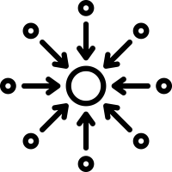

* **No Privacy** - Who is accessing this data?

# Solution

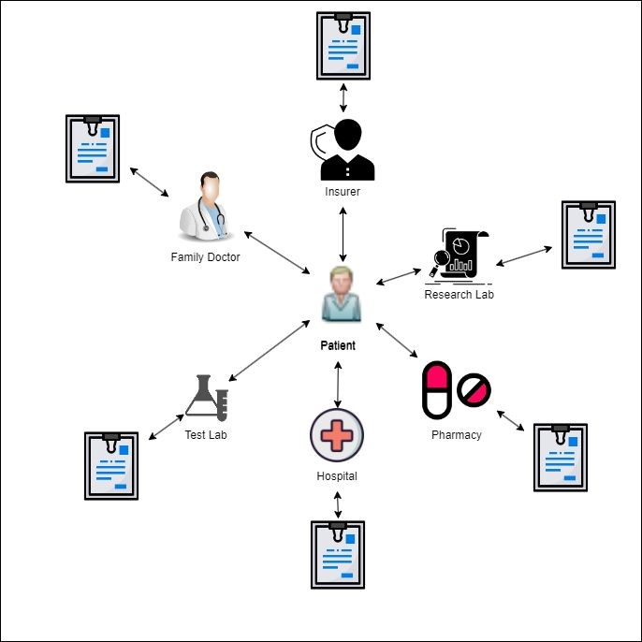

1. **Interoperability** - Different systems should be able to communicate with each other.
2. **Privacy control** - Patients should be able to control the access of their data.
3. **Blockchain** - Distributed ledger based on cryptography to improve security, reliability and transparency.

Current Future

Demo

# Roadmap



02

Integrate Phase - 2 by

Q4 2023

03

Mobile Application by

Q2 2024

04

01

Complete Phase - 1 by

Q2 2023

Step 1 Step 2 Step 3 Step 4

Go Live by

Q4 2024

# Market opportunities

1. 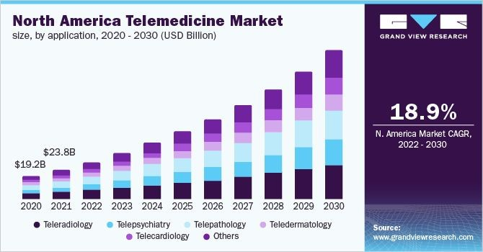**Telemedicine Market**  - NA market was valued at

$19.2 billion in 2020 & is estimated to grow at a CAGR of 18.9% from 2022 to 2030

1. **Benefits** - Approx $40 billion per year of insurance frauds are happening every year in US.

**Thank You**

